1. **Excel Power Pivot Data Model Relationships**

**Definition**:

Data model relationships in Power Pivot allow users to establish connections between different tables within a data model, enabling seamless data analysis and visualization.

**Purpose**:

To understand how to create and manage relationships between tables in Power Pivot to build effective data models for analysis.

**Key Concepts**:

* Primary and Foreign Keys
* One-to-Many Relationships
* Many-to-One Relationships
* Many-to-Many Relationships

**2. Establishing Relationships in Power Pivot**

* Creating Relationships:

Using Diagram View

Defining Relationship Cardinality

* Types of Relationships:

One-to-One Relationships

One-to-Many Relationships

Many-to-One Relationships

Many-to-Many Relationships

* Managing Relationships:

Editing Relationships

Deleting Relationships

Setting Relationship Properties

1. **Creating PivotTables based on Data Models**

We’ll walk through these steps together:

* Enable the data model
* Import the data tables
* Define relationships
* Build the PivotTable

Let’s get started.

### **Enable the data model**

First, we’ll need to enable the Power Pivot add-in. If you have Excel 2016+ for Windows, just click the **Data > Manage Data Model** ribbon command as shown below:



*Note: depending on your screen size, you may see the icon only and not the label.*

Clicking it the first time asks you to enable the add-ins:

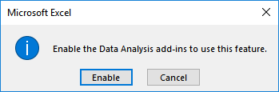

Once you click Enable, you are all set and should see a Power Pivot ribbon tab. Yay!

*Note: If you are on an earlier version of Excel for Windows, you’ll need to download and install the free Power Pivot add-in from the Microsoft website and follow the installation instructions for your version of Excel.*

### **Import the data tables**

Next, we import the data tables. In our case, we have some transactions stored in a DataTable workbook. The transactions have the account number but not the related account name. Fortunately, we have a little something called a chart of accounts, which is stored in the LookupTable workbook.

The step to import data tables will vary depending on where your source data is. To get started, click the **Power Pivot > Manage** ribbon command. This opens the Power Pivot window, shown below.

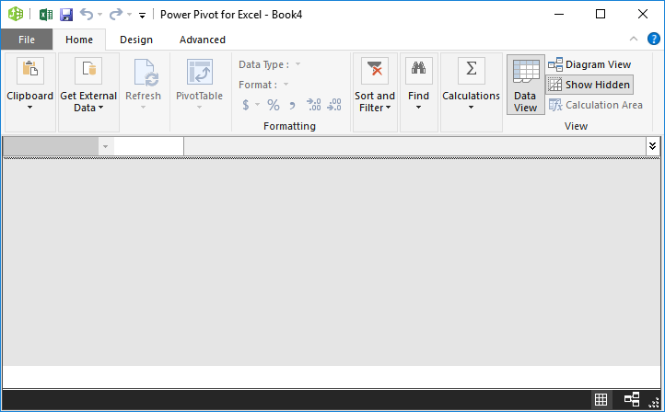

Use the **Get External Data** command to point to the underlying data source.

In our case, the data is in a couple of Excel files, so, we use the **Get External Data > From Other Sources** option, and then select **Excel File** in the resulting dialog. We **Browse** to the desired workbook and check **Use first row as column headers**. We finish the wizard and bam, the data is loaded into our data model, as shown below.

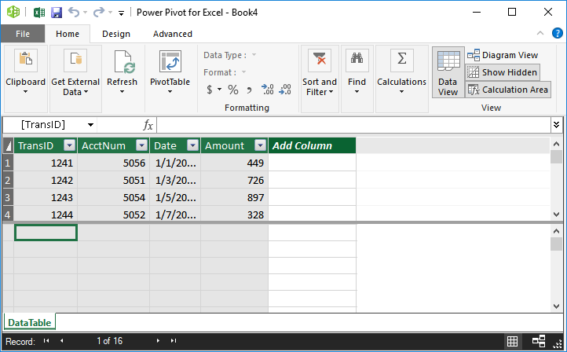

*Note: if you are creating a data model inside the workbook that has the tables, you can use the Power Pivot > Add to Data Model command instead.*

Next, we do the same thing to pull data from the LookupTable Excel file. The updated Power Pivot window is shown below.

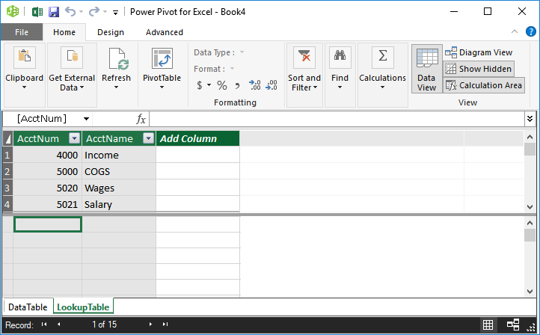

With our data loaded into the data model, we need to tell Excel how the tables are related (which columns are common between the tables) by defining the relationships.

### **Define relationships**

There are several ways to define relationships, but my favorite way is to use the visual diagram view. To toggle away from Data View (shown above), and Diagram view (shown below), simply click the **Home > Diagram View** command. We’ll now see the tables with the column names (instead of seeing the data transactions), as shown below.

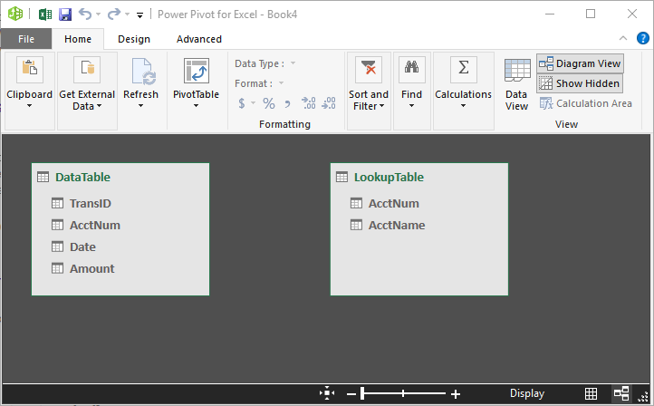

To define the relationship, **click** the **column name** from the **DataTable** and **drag** to the **related column** in the **LookupTable**. In our case, we are relating the DataTable’s AcctNum column to the LookupTable’s AcctNum column. Excel displays the relationship as shown below.

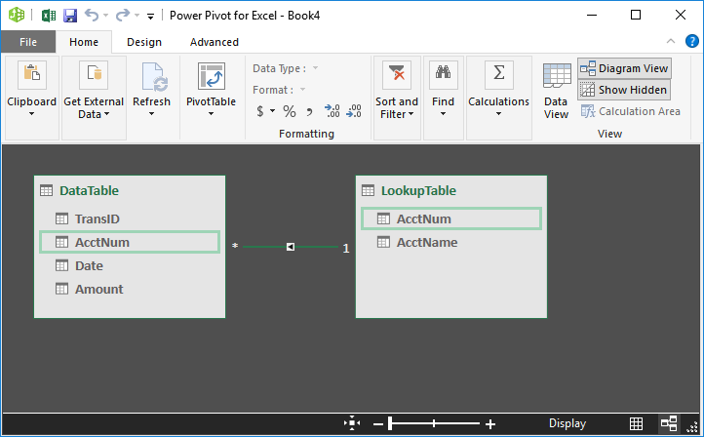

With our relationship defined, we can now build the PivotTable.

### **Build the PivotTable**

In the Power Pivot window, we just click the **PivotTable > PivotTable** command and select either a **New Worksheet** or an **Existing Worksheet** in the resulting **Create PivotTable** dialog. Once we click OK, bam, we see the familiar PivotTable field panel.

But, wait a sec … on closer inspection, it looks a little different from the traditional field panel. We typically see a list of fields that we can insert into the report. But now, we actually see the tables, and can expand each table to view the fields in each as shown below.

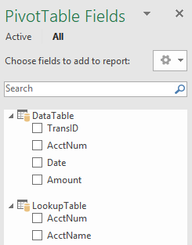

And, yes, we can pick fields from either or both of the tables for our report. For example, we want the AcctName from the LookupTable in Rows, and the Amount field from the DataTable as Values. And, bam … done!

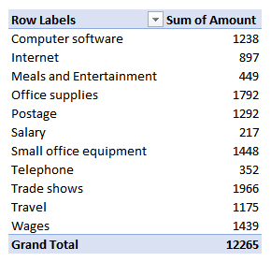

**Customizing PivotTables**:

Formatting PivotTables

Adding Slicers and Filters

**Using PivotCharts:**

Creating Dynamic Charts from PivotTables

Visualizing Data Trends and Patterns

**3. Advanced PivotTable Techniques**

* **Calculated Fields and Items:**

Adding Calculated Fields

Creating Custom Calculations

* **Filtering and Sorting:**
  + Applying Advanced Filters
  + Sorting Data within PivotTables
* **Using Timelines:**
  + Analyzing Time-Based Data with Timelines
  + Filtering Data by Date Ranges

1. **Excel Power Pivot KPIs**

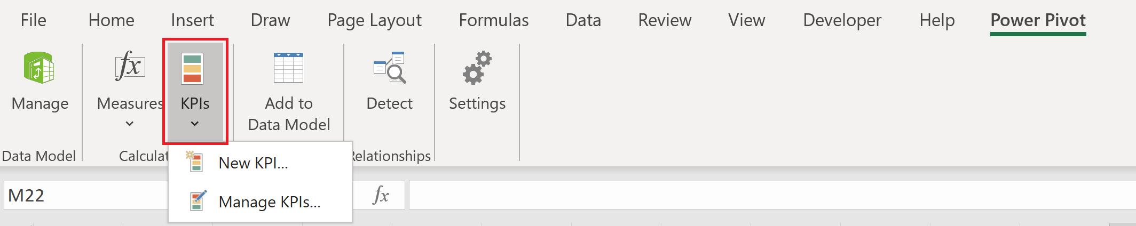

A Key Performance Indicator (KPI) is a quantifiable measurement for gauging business objectives *e.g.* measuring sales performance against target sales, comparing actual figures versus budget. A KPI includes a **base** value, a **target** value, and **status thresholds**:

* a **base** value is a calculated field that must result in a value, for example, can be an aggregate of sales or the profit for a specific period
* a **target** value is also a calculated field that results in a value, being a measure or an absolute value. For instance, a sales manager wishes to see how each department is performing, where the budget calculated field would represent the target value
* a **status threshold** is defined by the range between a low and high threshold, which is displayed with a graphic to help users easily determine the status of the **base** value compared to the **target** value.

**Let’s consider an example** of how to create a KPI in Power Pivot, using a **SalesData** table, by stores and by product types in the first quarter of FY20/21, which has already been loaded into the Power Pivot Data Model:

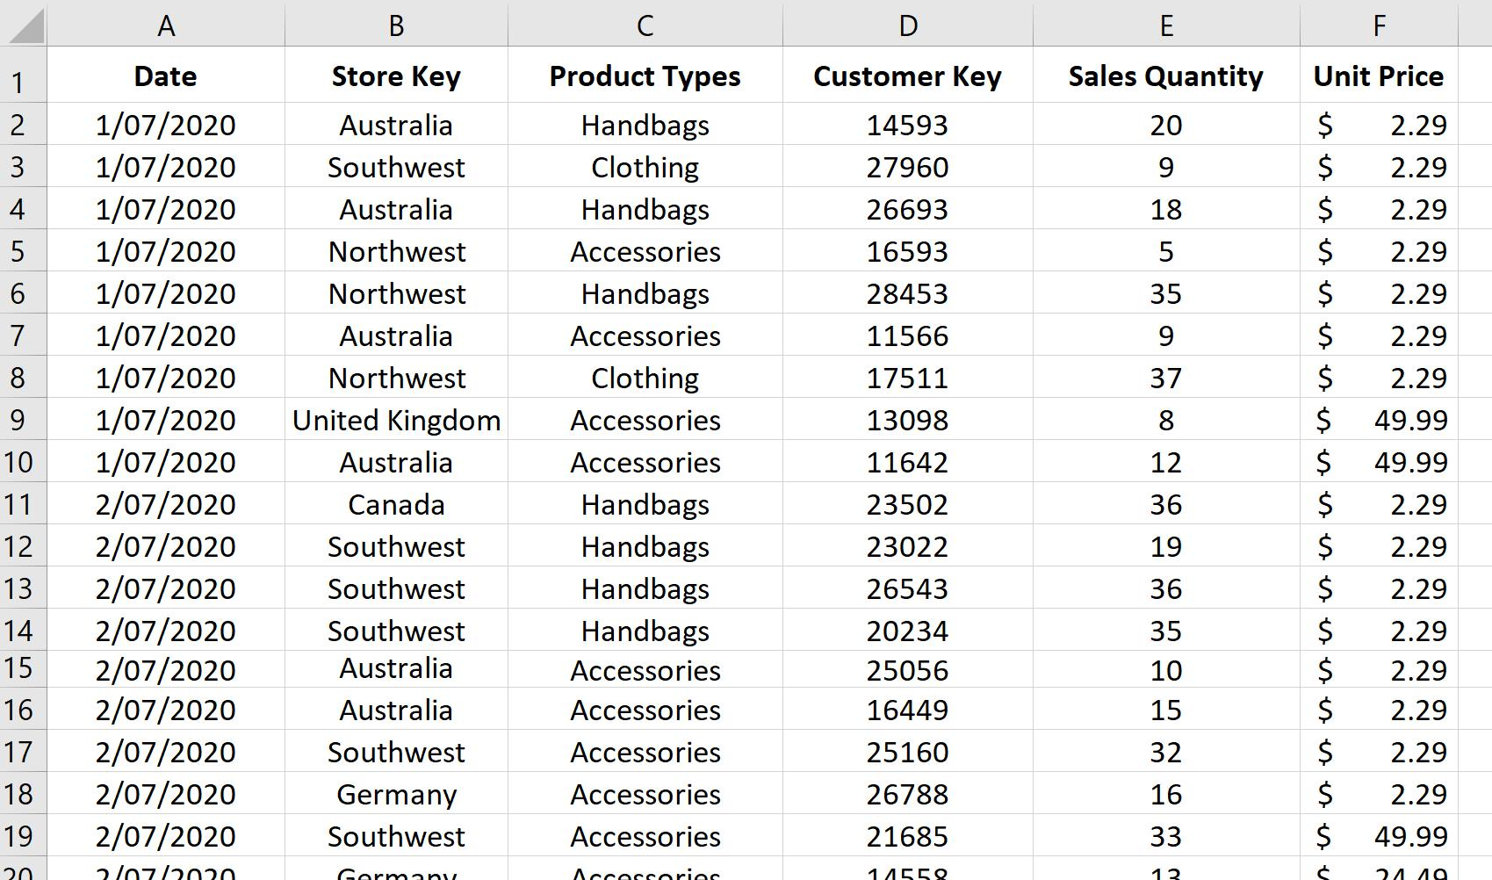

We will create a measure to get sales which will be the **base** value, from which we will create the KPI later:

**Total Sales:=SUMX(Sales, Sales[Sales Quantity]*Sales[Unit Price])**

We will create a PivotTable to see **Total Sales** by **Store Key**:

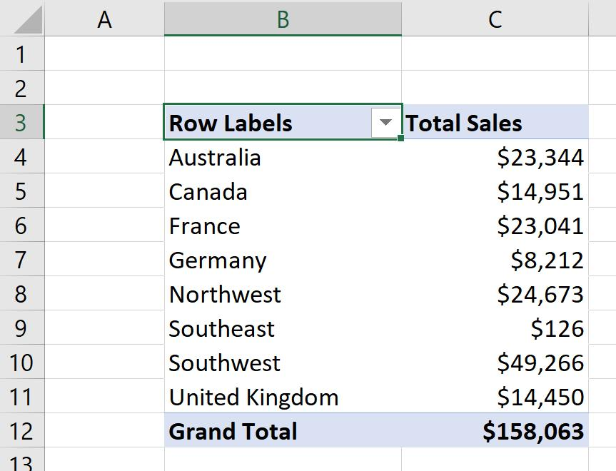

Now, we want to see how each store performs against a sales target, by creating a KPI.

We navigate to the ‘Power Pivot’ tab on the Ribbon,

choose **KPIs -> New KPI…,** where a Key Performance Indicator (KPI) dialog will appear. We will select **Total Sales** as the ‘KPI base field (value)’ and in the ‘Define target value’ section,

we will enter an ‘Absolute value’ of 30,000. We can also select the icon style and adjust the status threshold,

*e.g.* a red icon for **Total Sales** below $18,000, yellow for **Total Sales** between $18,000 and $24,000, and a green one for stores with **Total Sales** of over $24,000:

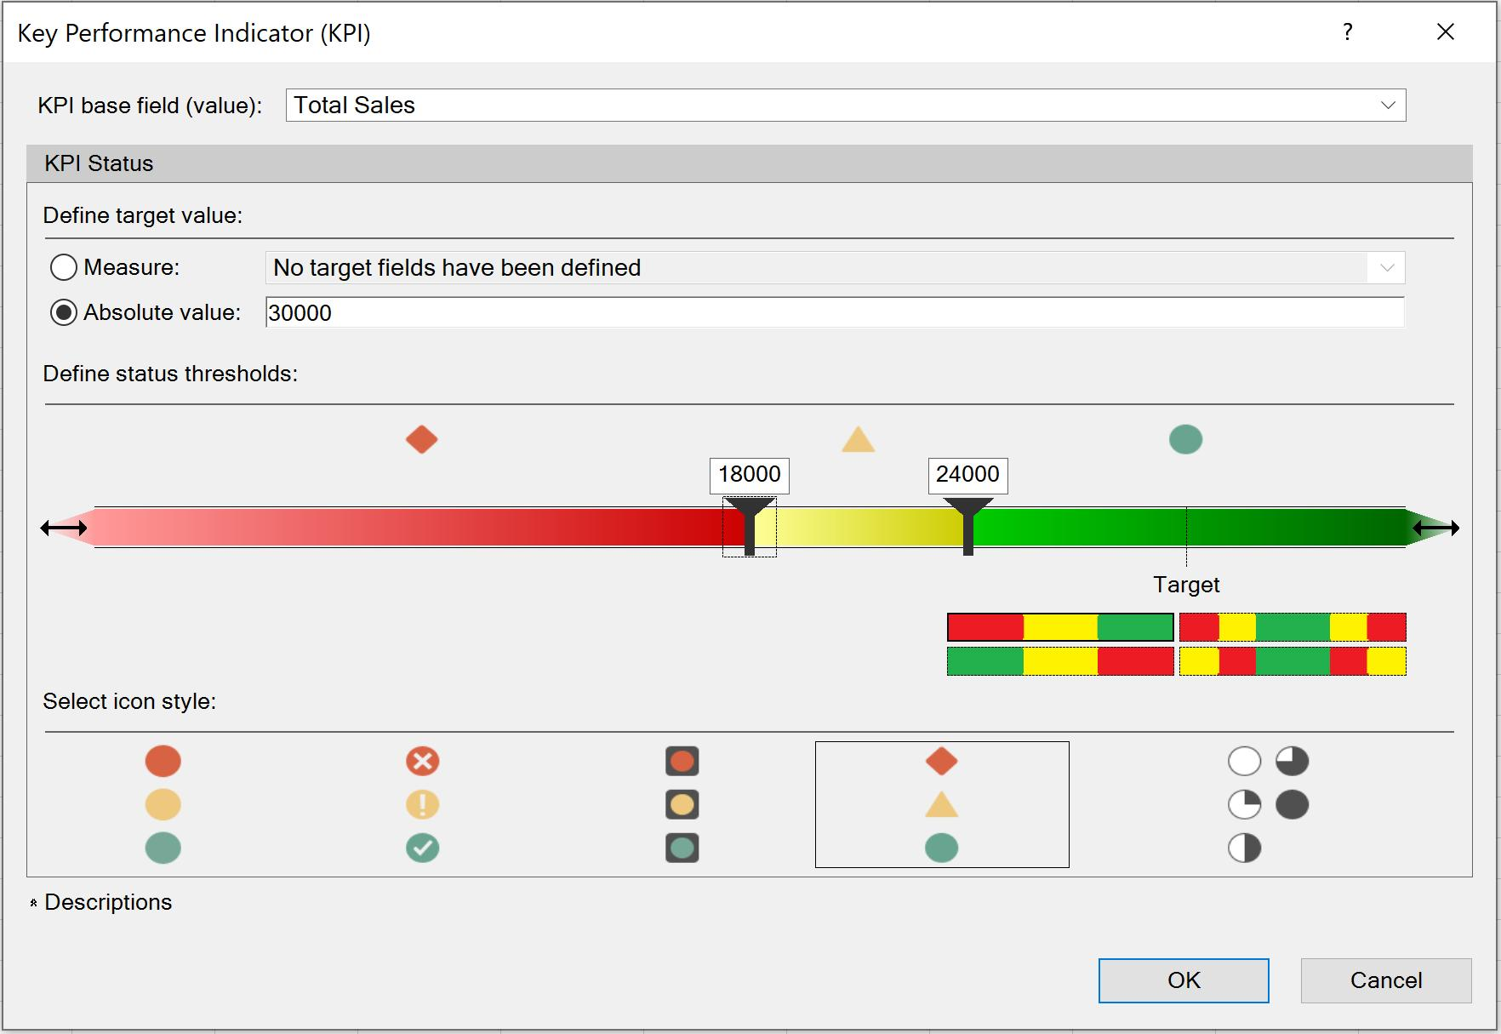

In the ‘PivotTable Fields’ pane, we can see a traffic light icon next to the **Total Sales** item, and it is expanded so that we can choose to also display the **Goal** (which is the **target** value) and **Status** (which are the coloured icons):

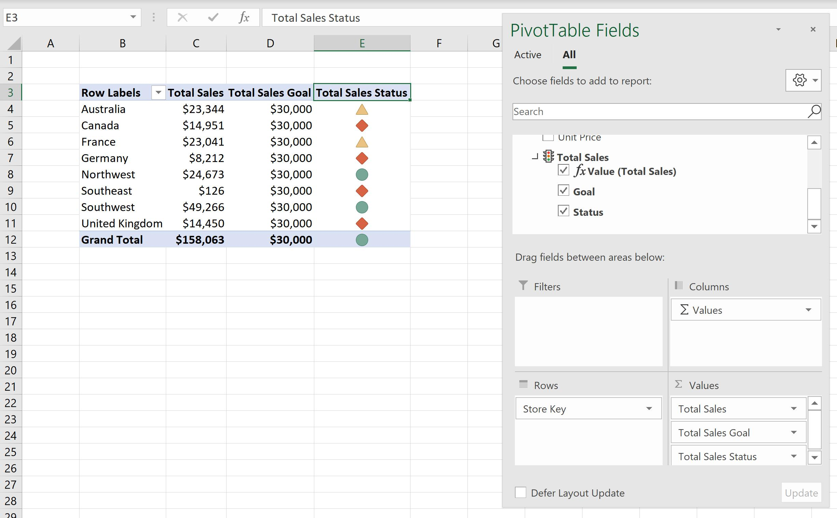

If we wish to modify the KPI, we can navigate back to the ‘Power Pivot’ tab on the Ribbon, click on **KPIs -> Manage KPIs…**, and choose a KPI we wish to adjust, by clicking Edit:

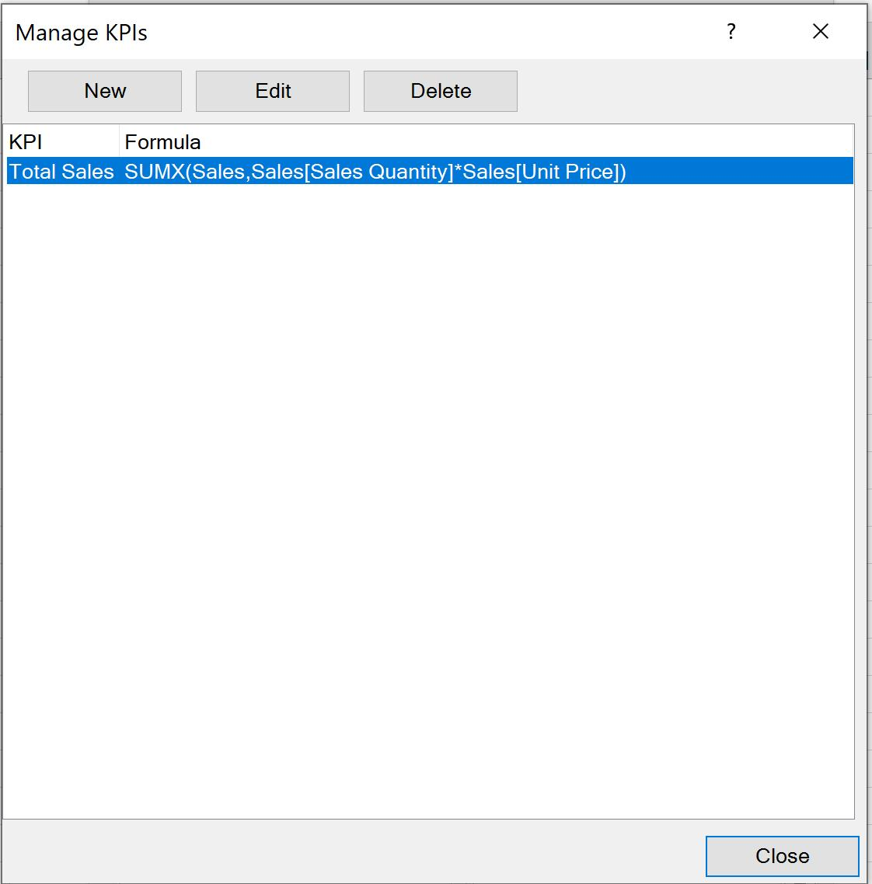

We can redefine the **target** value, icon style and **status thresholds**, then click OK:

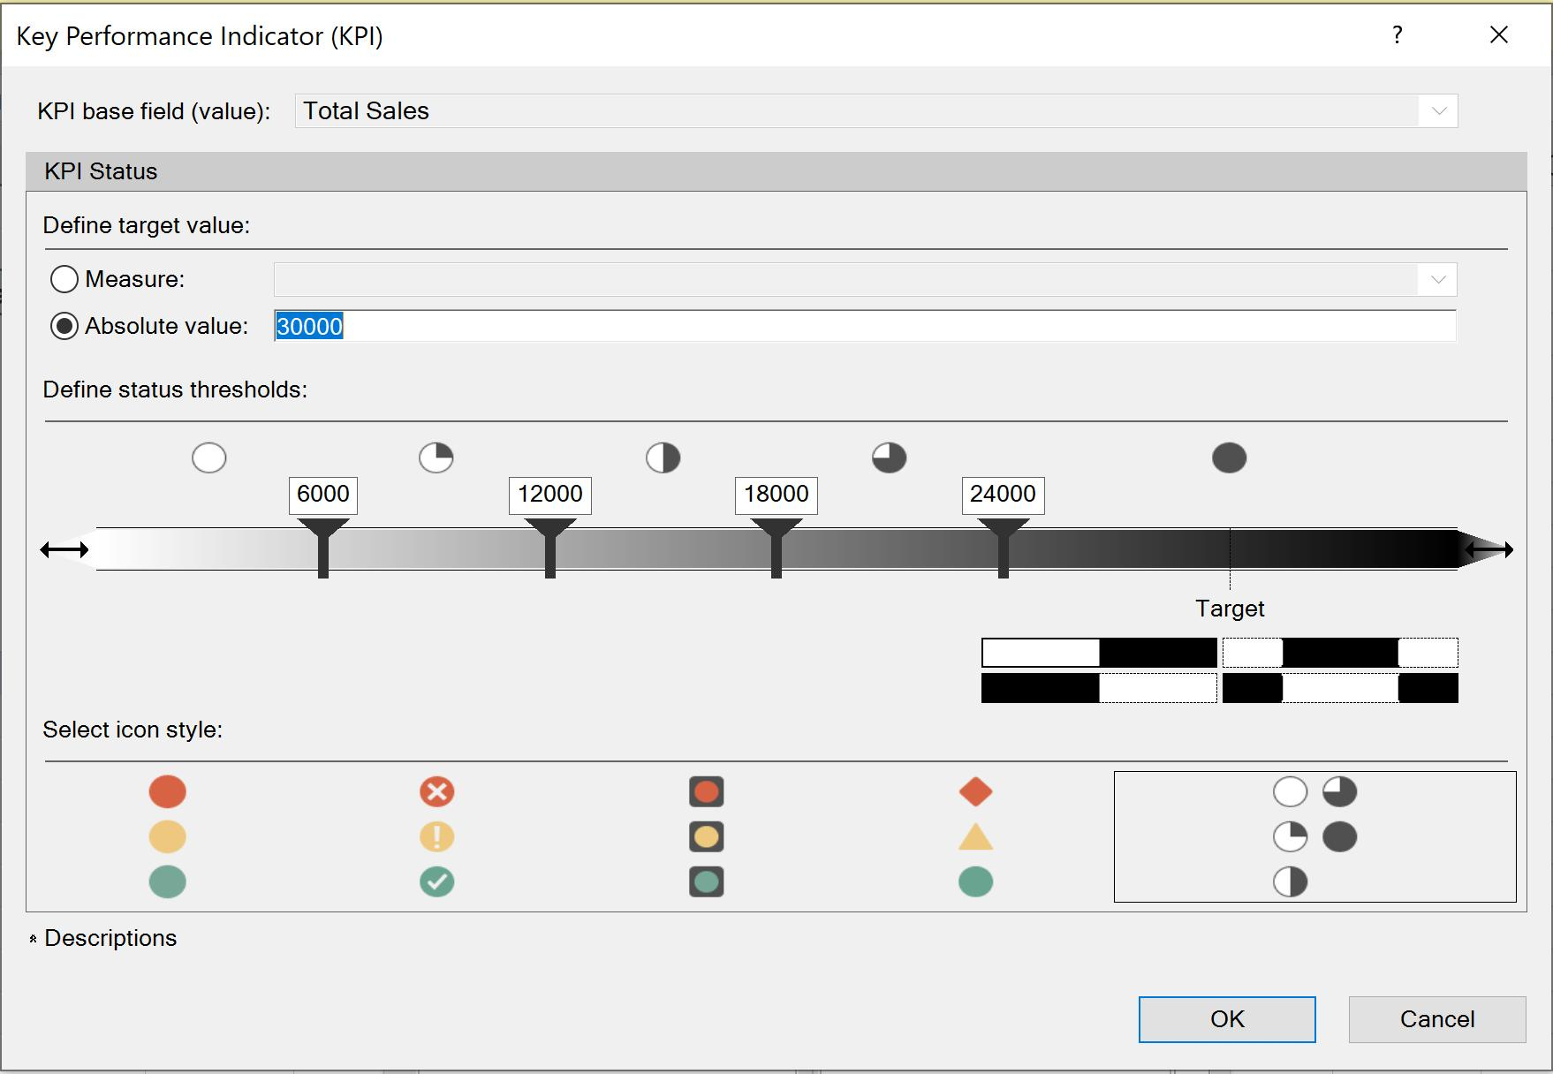

The KPI is now changed:

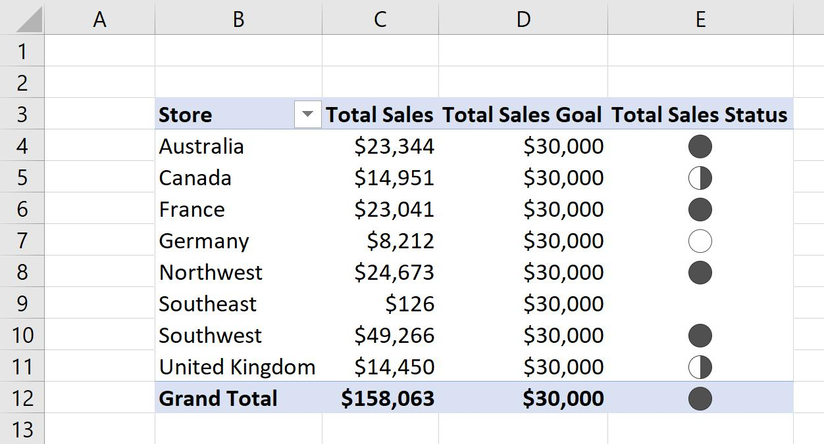

End.